TITLE OF LESSON: THE ***REAL*** TRANSFORMERS

CONTEXT OF LESSON: The lesson will have students discover the transformations (vertical and horizontal translations) that are applied when graphing absolute value, square root, and cube root functions. The lesson is geared to all students although an extension has been provided for more accelerated students. The lesson will set the stage for using transformations to graph other functions later in the year (ie.exponential and logarithmic) and beyond ( conic sections). We will revisit the functions in a future lesson regarding domain, range and real life modeling scenarios.

I will use this lesson in Algebra 2 during the first quarter after students have reviewed and discussed and have been assessed on the following Algebra 1 topics: Order of Operations, Graphing Linear Functions and Quadratic functions.

LEARNING OBJECTIVES AND ASSESSMENT:

|  |  |  |
| --- | --- | --- |
| **Learning Objective** | **Bloom** | **Assessment** |
| Given an equation of an absolute value, square root or cube root function, recognize and graph the parent function. | 2 | ***Observation****:* I will be rotating through the groups as they work and will be checking their graphs and equations for accuracy; providing guidance as needed.  The daily **warmup** will review the previous day’s lesson- the teacher will collect and record.  The teacher can immediately redirect those students who are struggling.  ***Rubric:*** All objectives in this investigation will be assessed through the Rubric that is included. |
| Given an equation of an absolute value, square root or cube root function, graph it using a translation of the parent function. | 3 | See above |
| Given the graph of an absolute value, square root, or cube root function, write the equation of the function. | 4 | See above |

RELATED 2009 VIRGINIA SOL: AII.6

The student will recognize the general shape of function (absolute value, square root, cube root, rational, polynomial, exponential, and logarithmic) families and will convert between graphic and symbolic forms of functions. A transformational approach to graphing will be employed.

Graphing calculators will be used as a tool to investigate the shapes and behaviors of these

functions.

**MATERIALS NEEDED:**

Each group of 2 needs a pencil and 2 other colors (pens work nicely)

The ***REAL*** TRANSFORMERS investigation sheet (Days 1-3)

Rubric

PROCEDURE

DAY 1

|  |  |  |
| --- | --- | --- |
| Time | Mathematical Tasks: Teacher | Student actions/ questions |
| 10 | Distribute warmup.  Guided discussion of answers to warmup. | Students complete the warmup |
| 5 | Introduce what a parent function is and explain the investigation.  Use the explanation found on the student handout. |  |
| 30 | Distribute Investigation #1 (graphs and analysis questions).  Students work in pairs.  They should finish investigation #1. If not, they will finish it as homework to be ready to go on to the 2nd investigation on Day 2.  *Teacher should be actively rotating through groups observing the graphs for accuracy and offering feedback. | For those students who seem to need feedback on every graph and question they answer: A self check is included in the student ws so students can monitor their own progress, instead of waiting for the teacher to give feedback. |

DAY 2

|  |  |  |
| --- | --- | --- |
| Time | Mathematical Tasks: Teacher | Student actions/questions |
| 10 | Distribute the Warmup:  Guided discussion of the warmup.  This is another way the teacher can monitor for understanding of the topics from investigation #1. | Students complete the warmup. |
| 30 | Distribute Investigation #2 (graphs and analysis questions).  Distribute the graphs part to Investigation #3, once they have shown they have completed Investigation #2.  Goal for today: Finish Investigation #2 and the graphs part to Investigation #3. | Once students see the shape of the absolute value graph and they see the same kind of shifting as in Investigation # 1, they should proceed through the rest at a faster pace.  ( This is what I noticed when I used this lesson last year)  *Teacher should be actively rotating through groups offering feedback.  Another self check has been provided on the student questions so they can monitor their progress. |
| 5 | Exit ticket : A quick check for understanding | Students do this individually and turn it in. Teacher can gear the next day’s warmup to discussing any issues with the concepts.i |

DAY 3:

|  |  |  |
| --- | --- | --- |
| Time | Mathematical Tasks | Anticipated Student Questions |
| 10 | Return the exit tickets from Day 2.  Discuss any issues that need to be clarified. |  |
| 30 | Distribute Analysis questions for Investigation #3.  After students finish the Investigation, give them the Summary questions to complete.  *Teacher should be actively rotating through groups observing the graphs for accuracy and offering feedback. | Students will get the shifts backwards. (move hor when vert should be used or shift the opposite directions)  Teacher should direct the student back to the appropriate part of the investigation that used hor and vert shifts.  The teacher can also suggest that the student plug in a number for the x value and check to see if the correct point was plotted by the transformations method.  Students will mix up the parent function graphs.  The teacher should direct the student back to the investigation to check. |
| 10 | Wrap- up; turn in investigation |  |

MEETING THE NEEDS OF ALL STUDENTS:

Teacher carefully planning the Grouping of students will assist those students who are below grade level. Lower level students could do a variation of this investigation where they could graph all on a calculator and make comparisons. An extension of the lesson ( accelerated students) would be to have students create their own investigation for vertical stretch or shrink of graphs.

WHAT COULD GO WRONG WITH THIS LESSON:

Aside from the student mistakes I have mentioned in the daily plans above, some students may not be able complete the analysis questions correctly because of calculation errors and inaccurate plotting of points. At that point, I would steer them in the direction of the calculator method I mentioned above in the meeting the needs of all students. I would then have them either come in before school or during their lunch (we have an hour lunch) to do some work with calculations and plotting points.

CONNECTION TO CTA:

I used this lesson last year. The following changes were made to incorporate gems that I picked up during CTA.

I included a rubric. Brian Nussbaum’s examples helped me to realize that a rubric not only helps the student define how they are performing, it is an easy way for the teacher to grade the project. I used the Rubistar site which made the process even easier.

I added the analysis questions. In last year’s lesson, I had students fill in blanks to summarize the investigation- Level 1 and 2 Bloom’s. In this lesson, students need to use a higher level of Bloom’s ; I have student’s comparing, analyzing, and making conjectures about functions they can’t graph or writing the symbolic form of an unfamiliar function given its graph.

|  |  |
| --- | --- |
| X | y |
| -4 | 4 |
| -1 | 1 |
| 0 | 0 |
| 1 | 1 |
| 2 | 2 |
| 4 | 4 |

**Warmup Day 1**

1. Describe the pattern.

Simplify.

2. =______ 3. =______ 4. =_______

**Warmup :Day 2**

1. Write the parent function for. ____________________

2. To graph , first graph the parent function, then shift all points ____ units _______

and ____ units _______

3. True or false? An absolute value function is a linear function. Why?

**Exit Ticket Day 2**

1. Which function represents a shift of the parent function 2 units right and 3 units up?

A) B)  C)  D) 

2. Rewrite the equation so that the graph will be a translation of 3 units down from the parent graph.

Parent function:

The REAL TRANSFORMERS

**An investigation!**

**Objectives:**

* Graph each function using the parent graph and transformations.
* Given a graph of the function, write the equation of the function.

Standard AII.6

The student will recognize the general shape of function (absolute value, square root, cube root,

rational, polynomial, exponential, and logarithmic) families and will convert between graphic

and symbolic forms of functions. A transformational approach to graphing will be employed.

Graphing calculators will be used as a tool to investigate the shapes and behaviors of these

functions.

**Materials needed:**

Pencil and 2 other colors (pens work nicely)

Investigation sheet for each partner

Rubric

**Grading:** The investigation will be turned in and scored according to the rubric.

As you investigate each function, you will first graph the ***parent function***.

A ***parent function*** is an equation from which all other functions are transformed. The parent function will resemble the shape of all other functions that are built (transformed) from it.

Directions:

Although *each student will turn in a copy of the investigation*, you will complete the investigations and the summary sheet with a partner.

I expect you to share the tasks. (ie. One partner do the calculations and complete the tables as the

partner plots the points, then switch rolls with the next investigation.)

(DAY 1) Investigation # 1: **Absolute Value** **Function**

* Complete the tables.
* Graph a-c on the same coordinate plane and graph d-f on the same plane below. Hint: record the color you use for parts b ,c, e, f to help you when you do the analysis questions.
* Answer the analysis questions.

**a)** Parent Function:  **b)**  **c)**

Graph in PENCIL Graph in different Graph in different

color from part **a** color from parts a and b.

|  |  |
| --- | --- |
|  |  |
| -2 |  |
| -1 |  |
| 0 |  |
| 1 |  |
| 2 |  |

|  |  |
| --- | --- |
|  |  |
| -2 |  |
| -1 |  |
| 0 |  |
| 1 |  |
| 2 |  |

|  |  |
| --- | --- |
|  |  |
| -2 |  |
| -1 |  |
| 0 |  |
| 1 |  |
| 2 |  |

**d)**  **e)**  **f)** 

parent function: Graph in PENCIL Graph in a different Graph in a different

color from part d. color from parts d and e.

|  |  |
| --- | --- |
|  |  |
| -2 |  |
| -1 |  |
| 0 |  |
| 1 |  |
| 2 |  |

|  |  |
| --- | --- |
|  |  |
| 1 |  |
| 2 |  |
| 3 |  |
| 4 |  |
| 5 |  |

|  |  |
| --- | --- |
|  |  |
| -6 |  |
| -5 |  |
| -4 |  |
| -3 |  |
| -2 |  |

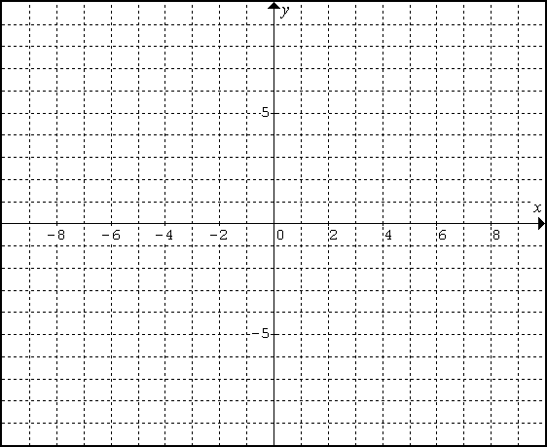**graphs a-c** **graphs d-f**



**Analysis (Absolute Value Functions)**

1. How are all 6 graphs similar? (list 2 ways)

______________________________________________________________

______________________________________________________________

2a. How does graph ***b*** differ from the graph of the parent function?

_____________________________________________________________

2b.What part of the equation in part ***b*** do you think accounted for this difference?

____________________________________________________________________

3a. How does graph ***c*** differ from the graph of the parent function?

_____________________________________________________________

3b. What part of the equation in part ***c*** do you think accounted for this difference?

_______________________________________________________________

4a. Without making a table, how would the graph of  compare to the parent function?

similar_________________________________different_________________________________

4b. Am I on track? The graph of would be the same shape as the parent function, but it would be shifted down 7 units. (If you are on track, please continue; otherwise, please raise your hand to clarify.)

5a. How does graph ***e*** differ from the graph of the parent function?

_________________________________________________________________________

5b. What part of the equation in part ***e*** do you think accounted for this difference?

_________________________________________________________________________

6a. How does graph ***f*** compare to the graph of the parent function?

____________________________________________

6b. What part of the equation in part ***f*** do you think accounted for this difference?

_____________________________________________

7a. Without making a table or a graph, how would the graph of  compare to the parent

function?

similarity________________________________difference_________________________

7b. Am I on track? It would have the same shape, but it would be shifted 6 units to the right of the parent function. Raise your hand to seek clarification, if needed.

8. How does each graph differ from the parent function, ?

( You should not have to look at the graph to u answer these.

___________________ _____________________

___________________ _____________________

___________________  ______________________

___________________ ______________________

(Day 2) Investigation #2: 

* Complete the tables.
* Graph a - c on the same coordinate plane. Graph d - e on the same coordinate plane.

(Don’t forget to record which colors represent which graphs.)

* Answer the analysis questions.

a) Parent **Function** :  **b)**  **c)**

graph in PENCIL Different color from **a** Different color from a and b

|  |  |
| --- | --- |
|  |  |
| 0 |  |
| 1 |  |
| 4 |  |
| 9 |  |

|  |  |
| --- | --- |
|  |  |
| 0 |  |
| 1 |  |
| 4 |  |
| 9 |  |

|  |  |
| --- | --- |
|  |  |
| 0 |  |
| 1 |  |
| 4 |  |
| 9 |  |

**d)**  **e)**  **f)** 

graph in pencil Different color from d Different color from d and e

|  |  |
| --- | --- |
|  |  |
| 0 |  |
| 1 |  |
| 4 |  |
| 9 |  |

|  |  |
| --- | --- |
|  |  |
| 1 |  |
| 2 |  |
| 5 |  |
| 10 |  |

|  |  |
| --- | --- |
|  |  |
| -5 |  |
| -4 |  |
| -1 |  |
| 4 |  |

**Graphs a - c**  **Graphs d - f**



Analysis ( Square Root Functions)

1. How are all 6 graphs similar?___________________________________________________________

2. How does graph ***b*** differ from the graph of the parent function? ________________________________

3. How does graph ***c*** differ from the graph of the parent function? ________________________________

4. Without making a table or a graph, how would the graph of  differ from the parent function?

____________________________________________________________________________________

5. How does graph ***e*** differ from the graph of the parent function? __________________________________

6. How does graph ***f*** differ from the graph of the parent function? __________________________________

7. Without making a table or a graph, how would the graph of  compare to the parent function?

Similarity:_____________________________________Difference:________________________________

8. How does each graph differ from the graph of parent function, ?

_____________________ _____________________

_____________________ _____________________

(Day 3) Investigation #3: 

***Complete the tables.***

***Graph a - c on the same coordinate plane. Graph d - e on the same coordinate plane.***

a) Parent Function:  **b)**  **c)** 

graph in PENCIL Different color from a Different color from a and b

|  |  |
| --- | --- |
|  |  |
| -8 |  |
| -1 |  |
| 0 |  |
| 1 |  |
| 8 |  |

|  |  |
| --- | --- |
|  |  |
| -8 |  |
| -1 |  |
| 0 |  |
| 1 |  |
| 8 |  |

|  |  |
| --- | --- |
|  |  |
| -8 |  |
| -1 |  |
| 0 |  |
| 1 |  |
| 8 |  |

**d)**  **e)**  **f)** 

graph in PENCIL Different color from d Different color from d and e

|  |  |
| --- | --- |
|  |  |
| -8 |  |
| -1 |  |
| 0 |  |
| 1 |  |
| 8 |  |

|  |  |
| --- | --- |
|  |  |
| -6 |  |
| 1 |  |
| 2 |  |
| 3 |  |
| 10 |  |

|  |  |
| --- | --- |
|  |  |
| -9 |  |
| -2 |  |
| -1 |  |
| 0 |  |
| 7 |  |

Graphs a - c Graphs d - f



Analysis : Cube Root Function

1. How are all 6 graphs similar?___________________________________________________________

2. Using what you have discovered in the investigations for Absolute Value and Square Root Functions, which graphs from above should have been shifted vertically (up/down) from the parent function? (Make sure your graphs show this.)

________________________________ Explain how you know this just by looking at the equations. Be specific.

_____________________________________________________________________________________

_____________________________________________________________________________________

3. Which graphs from above should have been shifted horizontally (left/right) from the parent function? (Make sure your graphs show this.)

________________________________ Explain how you know this just by looking at the equations. Be specific .

_____________________________________________________________________________________

_____________________________________________________________________________________

4. Without making a table or a graph, explain how each graph would differ from the parent function,  .

 ______________________  ______________________

 _____________________ ______________________

 _____________________  _____________________

**SUMMARY**

I. For each function below,

a) Name the function (quadratic, abs value)

b) Graph the parent function- you may use a table.

c) Use what you know about transformations of graphs to describe the shift for each.

d) Graph the function. .(Think of the shift!)

1.  2. 

a)_______________ c)_______________ a)_______________ c)_______________

3.  4. 

a)_______________ c)_______________ a) _______________ c) _______________

5. _____________ 6. 

a)_______________ c)_______________ a)_______________ c) _______________



II. A) Write the name of each function represented by the graph.

B) Write the equation that represents each function.

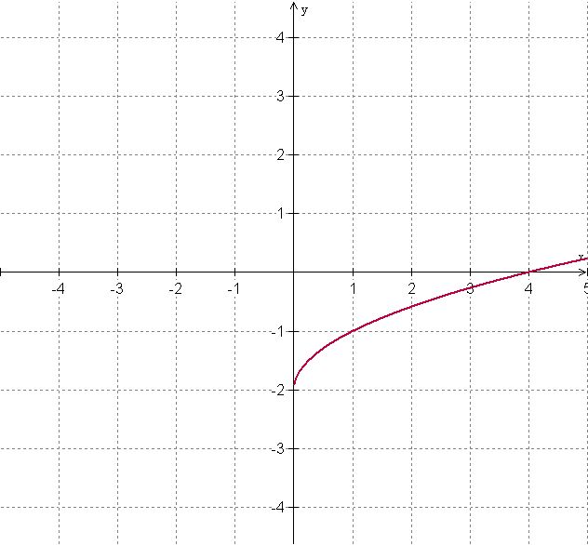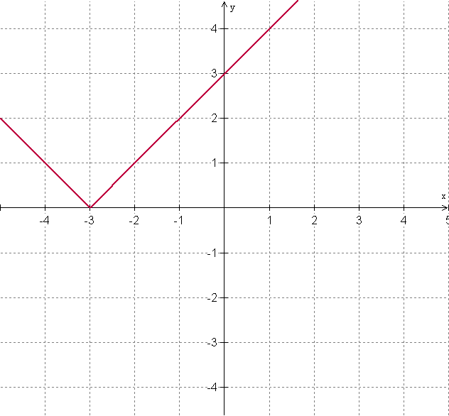7. a)_______________ b)______________ 8. a)___________ b) _____________

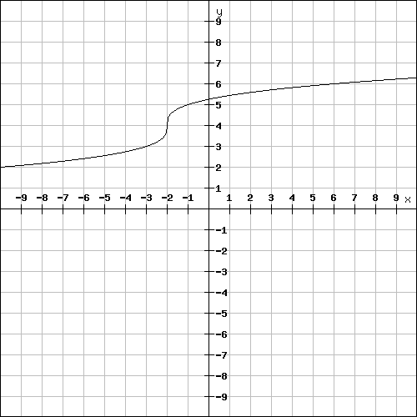9. a)________________ b)_______________

|  |  |
| --- | --- |
| |  | | --- | | Graphing : Quadratic and Absolute Value Functions Teacher Name: **Mrs. Dawson**    Student Name:     ________________________________________ | |

|  |  |  |  |  |
| --- | --- | --- | --- | --- |
| CATEGORY | **4** | **3** | **2** | **1** |
| **Accuracy of plot** | All calculations in tables are correct and all points are accurately plotted | Some miscalculations or inaccurate plotting of points | Contains some errors in calculations and inaccurate plotting of points | Many errors in plotting and many miscalculations |
| **Neatness and organization** | 3 colors are used; All graphs are neat and easy to read | 3 colors are used; Most of the graphs are neat and easy to read | Less than 3 different colors used. Most of the graphs are neat and easy to read | Less than 3 colors used; Many graphs are difficult to read. |
| **Analysis Questions** | Answers are detailed and clear. | Some explanations aren't clear. | Explanations are a little difficult to understand. Some questions not answered. | Difficult to understand many explanations. Many questions not answered |
| **Summary sheet** | Shows full understanding of concept of graphing by translations | Shows a good understanding of graphing by translations | Shows a fair understanding of graphing by translation. | Does not seem to understand the topic very well. |